
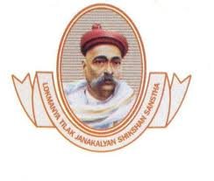
Lokmanya Tilak Jankalyan Shikshan Sanstha's
PRIYADARSHINI COLLEGE OF ENGINEERING
(An Autonomous Institute Affiliated to R.T.M.Nagpur University, Nagpur)
Near CRPF Campus, Hingna Road, Nagpur-440 019, Maharashtra (India)
Phone: 07104 - 299381, Fax: 07104 - 299648
E-mail: principal.pce.ngp@gmail.com, www.pcenagpur.edu.in
AICTE ID No. 5435581; DTE CODE No. 4123; UNIVERSITY CODE No. 278
Accredited with Grade "A+" by NAAC

DEPARTMENT OF Artificial Intelligence & Data Science

Mini Project on
Vocational Skill Enhancement Course -IV
(24UAI604P)
" Restaurant Website with Table Reservation System "
FOR
B. Tech VIth SEMESTER
Student Name: Mr. Abhishek Akhand (224)
Section: B
Roll no:224
Academic Year 2025-26
Index
Sr no | Content | Page no
1 | Abstract | 3
2 | Introduction | 4
3 | Architecture Diagram / Flowchart | 5
4 | Implementation  Tools and technologies used  Code snippets | 6
5 | Results  Output screenshots  Explanation of results | 8

Abstract

Abhishek Restaurant Website is a client-side web application developed to showcase the restaurant's menu, story, chef's specials, customer reviews, and a live table reservation system. The platform features a rich, visually immersive interface built for authentic Indian cuisine — from tandoori starters to regional thalis — allowing guests to explore the full menu with category filtering, add items to a cart, and book a table directly from the website.
The reservation module collects guest details (name, phone, date, time, number of guests, and occasion) and provides instant confirmation feedback via an animated toast notification. The menu section dynamically renders 23 dishes across 7 categories using a JavaScript data array, with real-time category tab filtering and veg/non-veg indicators.
The project uses no backend server; all logic runs entirely in the browser using vanilla HTML, CSS, and JavaScript. It features a warm saffron-and-gold themed responsive design with smooth scroll animations, a marquee ticker of signature dishes, and a sticky navigation bar — suitable for both desktop and mobile devices.
This project demonstrates the use of modern frontend technologies to build a complete, interactive, and visually refined restaurant website without any backend infrastructure.

Introduction

With the rise of digital presence for local businesses, especially in the food and hospitality sector, there is a growing need for restaurants to have engaging, interactive websites. Traditional restaurant platforms often require complex backends, content management systems, or expensive hosting. Abhishek Restaurant's website solves this by providing a fully browser-based, single-page web application.
The system is built as a single-page web app with the following capabilities:
- Hero section with restaurant branding, tagline (Asli Swad, Dil Se Pakaya), stats, and call-to-action buttons
- About section highlighting the restaurant's 18+ year legacy, clay tandoor, and fresh ingredients
- Dynamic menu rendering with 23 dishes across 7 categories (Starters, Main Course, Breads, Rice & Biryani, Desserts, Drinks)
- Veg/Non-veg badge and spice-level indicator per dish
- Chef's Special Thali section with 4 curated thali combos and pricing
- Guest reviews section with star ratings and reviewer details
- Table reservation form with name, phone, date, time, guest count, occasion, and special request fields
- Toast notification for instant reservation confirmation feedback
Unlike traditional restaurant platforms, this website:
- Works entirely in the browser with no server required
- Does not require installation, login, or a database
- Features a premium dark-and-cream design using CSS custom properties and smooth animations
- Provides instant feedback on all user interactions via toast notifications
This project is especially useful for understanding how to build interactive, responsive, real-world business websites using only frontend technologies.

Architecture Diagram / Flowchart

Architecture Overview
The system follows a fully client-side architecture with four logical layers:
- User Interface (Frontend) — Built using HTML and CSS; provides navbar, hero section, marquee ticker, about section, menu grid with tabs, specials cards, reviews section, reservation form, cart float, and footer
- Application Logic (JavaScript) — Handles menu rendering, category tab filtering, cart management, reservation validation, scroll-reveal animations, and toast notifications
- Data Layer (JS Array) — In-memory dishes array with 23 items across 7 categories; thali specials as static HTML; no backend required
- Feedback Layer — Toast notifications, animated scroll reveals (IntersectionObserver), marquee animation, sticky nav scroll effect
System Flowchart
START
Load Web Application (HTML + CSS + JS)
Initialize Menu Data (18 items, 6 categories)
Render Navbar, Hero, Marquee, About, Menu Grid, Specials, Reviews, Reserve, Footer
---- USER INTERACTION ----
[Category Tab Click] filterCategory(cat)
-> Re-render filtered dishes from dishes[] array
[Add to Cart] addToCart(btn)
-> Increment cartCount -> Show float cart badge -> Button turns green for 1.2s
[Reserve Table] submitReservation()
-> Validate: Name, Phone, Date (all required)
-> Show Toast: '<Name> ji, table book ho gaya! Milte hain <date> ko.'
-> Clear form fields after confirmation
[Scroll Down]
-> IntersectionObserver triggers .reveal.visible on sections
-> Navbar gets .scrolled class for condensed padding
END / REPEAT

Implementation

Tools and Technologies Used
Technology | Purpose
HTML | Structure of the web page — nav, hero, marquee, about, menu grid, specials, reviews, reservation form, footer
CSS (Custom Properties) | Styling, saffron-gold theme, animations (fadeUp, rotateSlow, marquee, slideIn), responsive layout
JavaScript (Vanilla) | Core logic — menu rendering, category filtering, cart management, reservation validation, scroll reveal
Google Fonts API | Playfair Display (headings, brand name) and Poppins (body text) for premium typography
JS Array (In-Memory) | Data persistence — all 23 menu items stored as JS objects at runtime; no database required
Code Snippets
- Menu Data Structure (menuData Array)

const dishes = [
{ name: 'Paneer Tikka', cat: 'starter', emoji: '🧀', color: 'c1',
veg: true, spice: 'Medium',
desc: 'Marinated cottage cheese grilled in clay tandoor...', price: 220 },
{ name: 'Butter Chicken', cat: 'main', emoji: '🍛', color: 'c1',
veg: false, spice: 'Medium',
desc: 'Classic Murgh Makhani in rich tomato-cream gravy...', price: 340 },
// 23 total items across 7 categories
];

- Render Menu Function

function renderMenu(cat) {
const grid = document.getElementById('menuGrid');
const filtered = cat === 'all' ? dishes
: dishes.filter(d => d.cat === cat);
grid.innerHTML = filtered.map(d => `
<div class='dish-card'>
<div class='dish-img ${d.color}'>
<span>${d.emoji}</span>
<span class='veg-badge ${d.veg ? 'veg' : 'nonveg'}'></span>
${d.spice !== 'None' ? `<span class='spice'>${d.spice}</span>` : ''}
</div>
<div class='dish-body'>
<div class='dish-name'>${d.name}</div>
<div class='dish-desc'>${d.desc}</div>
<div class='dish-footer'>
<div class='dish-price'>₹${d.price} <span>/ plate</span></div>
<button class='add-btn' onclick='addToCart(this)'>+</button>
</div>
</div>
</div>
`).join('');
}

- Add to Cart Function

function addToCart(btn) {
cartCount++;
document.getElementById('cartCount').textContent = cartCount;
const cf = document.getElementById('cartFloat');
cf.style.display = 'flex';
btn.textContent = '✓';
btn.style.background = '#2d7a3a';
setTimeout(() => {
btn.textContent = '+';
btn.style.background = 'var(--saffron)';
}, 1200);
}

- Category Tab Filter
document.querySelectorAll('.menu-tab').forEach(tab => {
tab.addEventListener('click', function() {
document.querySelectorAll('.menu-tab')
.forEach(t => t.classList.remove('active'));
this.classList.add('active');
activeTab = this.dataset.cat;
renderMenu(activeTab);
});
});

- Reservation / Submit Function

function submitReservation() {
const name = document.getElementById('rName').value.trim();
const phone = document.getElementById('rPhone').value.trim();
const date = document.getElementById('rDate').value;
if (!name || !phone || !date) {
alert('Please fill in Name, Phone and Date!');
return;
}
const toast = document.getElementById('toast');
toast.style.display = 'block';
toast.textContent = `✅ ${name} ji, table book ho gaya! Milte hain ${date} ko.`;
setTimeout(() => { toast.style.display = 'none'; }, 4000);
// Clear form fields
['rName','rPhone','rDate','rNote'].forEach(id =>
document.getElementById(id).value = ''
);
}

- Scroll Reveal (IntersectionObserver)

const observer = new IntersectionObserver((entries) => {
entries.forEach(e => {
if (e.isIntersecting) e.target.classList.add('visible');
});
}, { threshold: 0.12 });
document.querySelectorAll('.reveal').forEach(el => observer.observe(el));

- Navbar Scroll Effect

window.addEventListener('scroll', () => {
const nav = document.getElementById('navbar');
nav.classList.toggle('scrolled', window.scrollY > 60);
});

8. Toast Notification (CSS Animation)

.toast {
display: none;
position: fixed; bottom: 2rem; right: 2rem; z-index: 999;
background: #2d7a3a; color: white;
padding: 1rem 1.5rem; border-radius: 12px;
animation: slideIn 0.4s ease;
}
@keyframes slideIn {
from { transform: translateX(60px); opacity: 0; }
to { transform: translateX(0); opacity: 1; }
}

9. Marquee Ticker (CSS Animation)

.marquee-track {
display: inline-block;
animation: marquee 20s linear infinite;
}
@keyframes marquee {
from { transform: translateX(0); }
to { transform: translateX(-50%); }
}

10. Initial Setup (Auto Load on Script Execute)

// Called immediately when script block loads at page bottom
renderMenu('all');
// Scroll reveal & navbar listeners also initialized at this point.

Results

Output Screenshots
The following sections describe the expected output screens of the Abhishek Restaurant website:

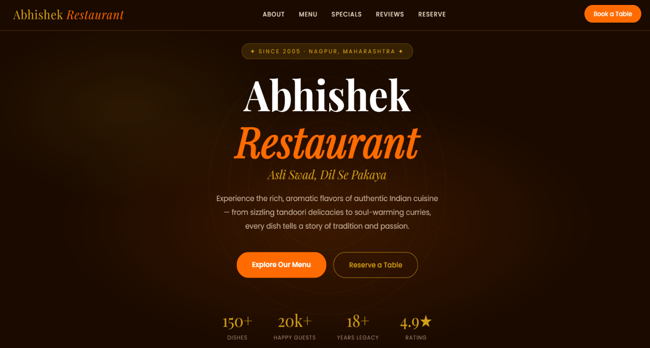
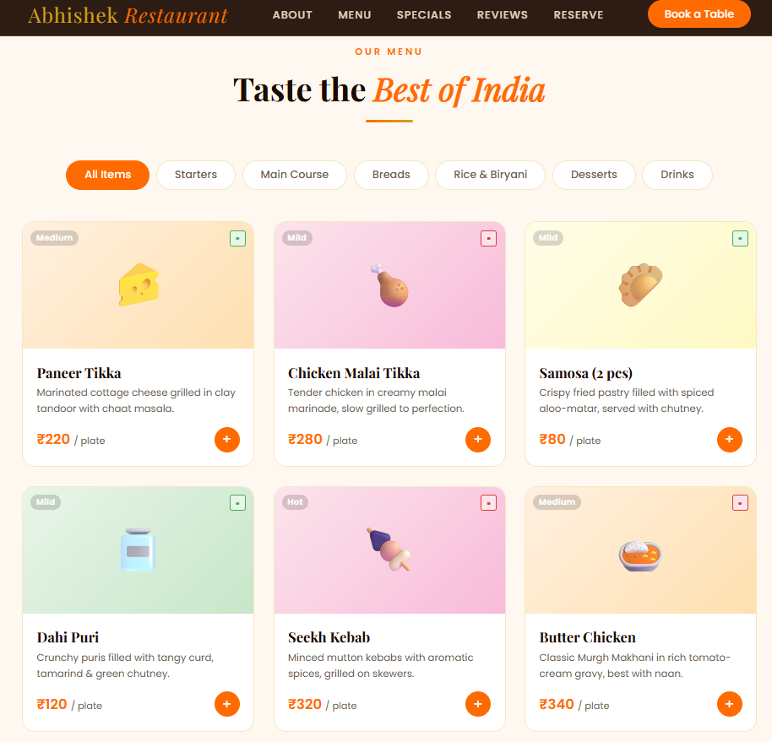
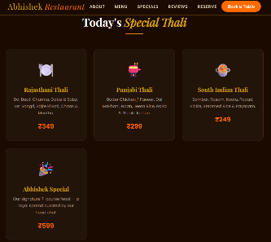
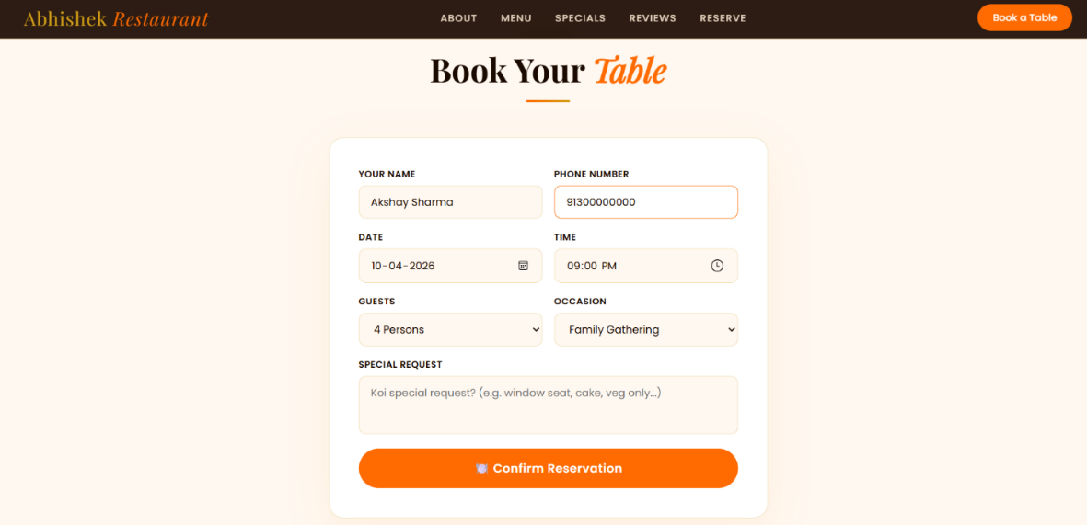

Explanation of Results

- The menu renders all 23 dishes dynamically from the dishes JS array on page load using renderMenu('all')
- Category filter tabs correctly filter and re-render the menu grid in real time when clicked
- Veg (green circle) and Non-veg (red circle) badges are shown on every dish card based on the veg flag in data
- Spice level badge (Mild / Medium / Hot) is conditionally rendered only when spice !== 'None'
- Add to Cart button increments the cartCount, shows the cart float badge, and turns green for 1.2 seconds on click
- Chef's Specials section renders 4 thali cards with name, ingredients, and price in INR from static HTML
- Customer reviews section displays star ratings, review text in Hindi/English, reviewer name, and city
- Reservation form validates Name, Phone, and Date before submission; missing fields trigger an alert()
- On successful reservation, a green toast notification appears for 4 seconds with a personalized Hindi confirmation message
- IntersectionObserver adds .visible class to .reveal elements when they enter viewport, triggering fade-up transitions
- Navbar condenses from 1rem to 0.6rem padding when scrolled past 60px via the .scrolled class toggle
- Hamburger menu appears on mobile (max-width: 768px) and toggles nav-links as a vertical dropdown
- Marquee ticker continuously scrolls signature dish names (Butter Chicken, Dal Makhani, Biryani, etc.) at 20s loop
- The application is fully responsive across desktop and mobile with CSS media queries at 768px and 480px breakpoints
- No backend or database is required; the entire app loads instantly with zero server latency

